FEW SUCCESS STORIES AND QUOTATIONS
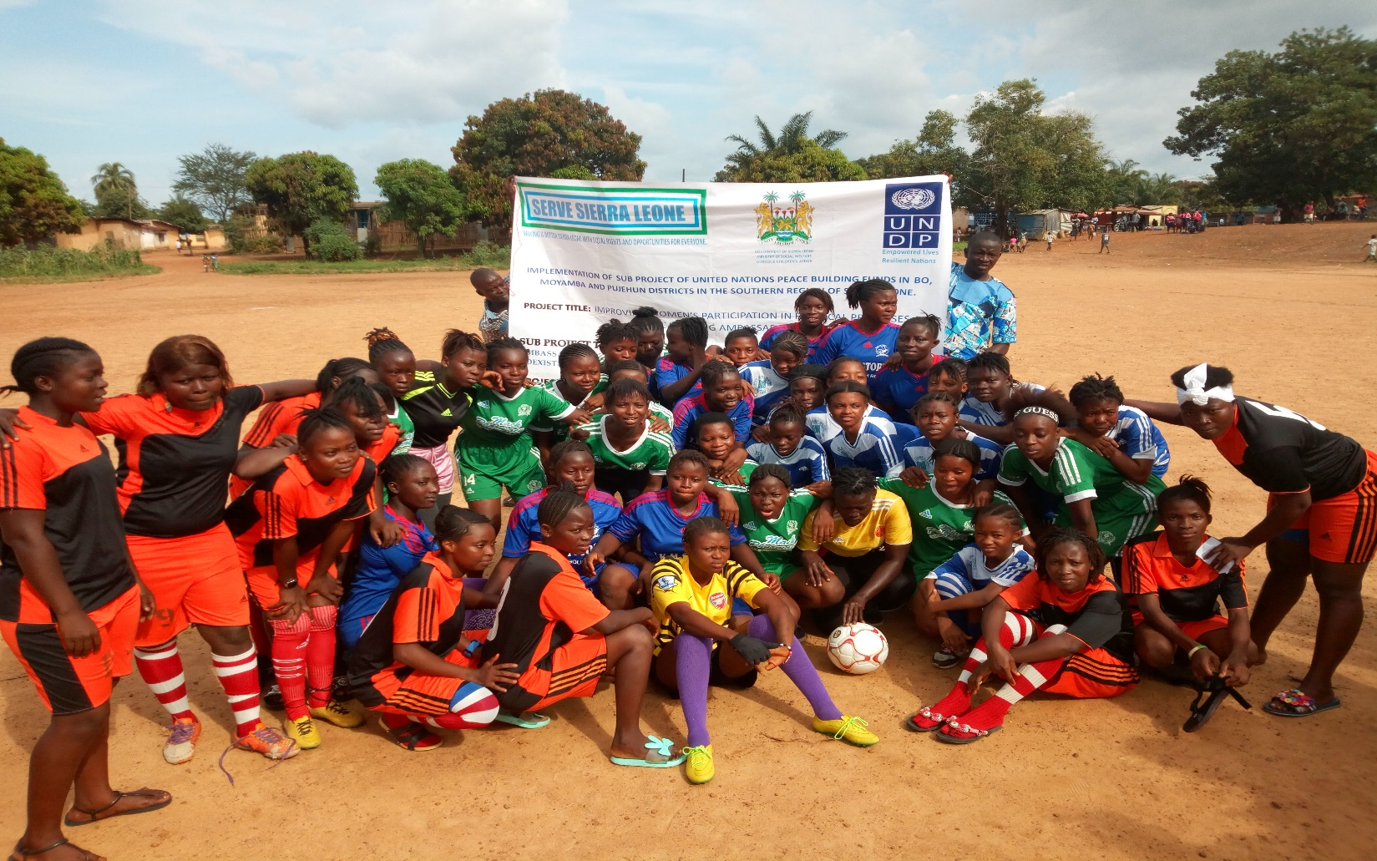

SUCCESS STORY: The Female Football peace gala games conducted SERVE SIERRA LEONE in Bo, Moyamba and Pujehun districts promoted social cohesion as conflicting communities were brought together through sporting activities, and got the public around a widespread action of promoting awareness on peace education, community reconciliation, and gender equality in peace building, tolerance of diversities, peaceful coexistence and community cohesion.

QUOTATIONS:

- Miss Jattu Kallon-football captain, “I felt so respected and important because UNDP gave me the opportunity to use my footballing skills to promote peace and unity in my community and in other communities”

- Joseph Lansana Boima-father of female footballer “I was shocked to see my daughter play and interact peacefully with other kids from other political parties. When the goal was scored against my daughter’s team, I was surprised to see people from different political parties and communities celebrate the football girls together.

- Aminata Mansaray during a lessons learnt exercise after the Tug of war and Peace had this to say “When we did the Tug of war, we pulled hard enough and our team won, as we were able to drag the other team but my happiness was short lived when I realized that my friend on the losing side had blisters and her games tunic was covered with mud. With the Tug of Peace, it was a win-win situation and so we were all happy”.

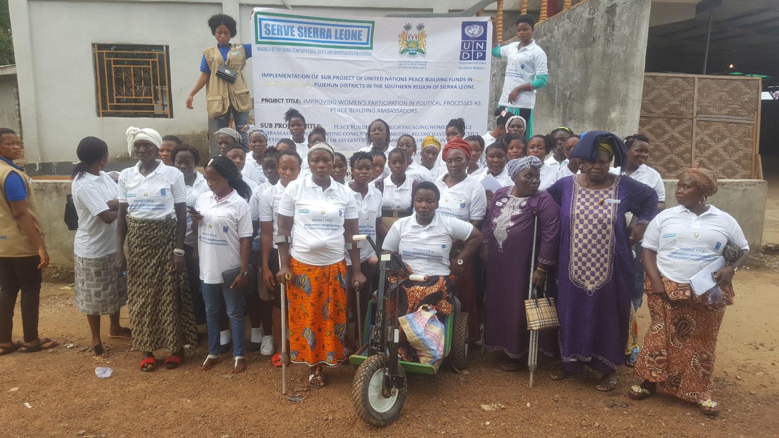

SUCCESS STORIES: SERVE Sierra Leone peace building interventions created the unique opportunity for women with disabilities to be provided with the require space/platform for their voices to be heard for increased participation and contributions to the peace building efforts, conflict prevention and inclusive governance. This opportunity complements the efforts of UNDP Sierra Leone and UNDP Global, in attaining the goal and objectives of UN Convention on the Rights of Persons with Disabilities.

QUOTATIONS:

- Haja M Kemokai- Physically challenged Teacher and project participant in Pujehun district “we disabled women are doubled disadvantaged and are victims of neglect-first as women and then as disabled. We are not represented in local councils, our voices are not heard in peace building and conflict prevention programs in our communities. Consequently, we are often absent in development processes. We are very hopeful that the narrative will change with this awareness raising programme. We therefore look forward to refresher programmes of this nature”

- Jeneba Rogers- Traditional Head and beneficiary with disability in Pujehun district “as a victim of war I lost my limb as it was chopped of by rebels during civil war. Life has been difficult but electoral violence in my community always remind me of the sad pasts and worsen my vulnerability
- Makorma Massaquoi: Beneficiary with Disability in Pujehun District. “I am a victim of the 2012 political violence between APC and SLPP party supporters which left me disabled. I wish SERVE SL and UNDP could organize a peace building program that will bring victims of political violence and politicians together, so that they can see the destruction created by their violent political ambitions.

5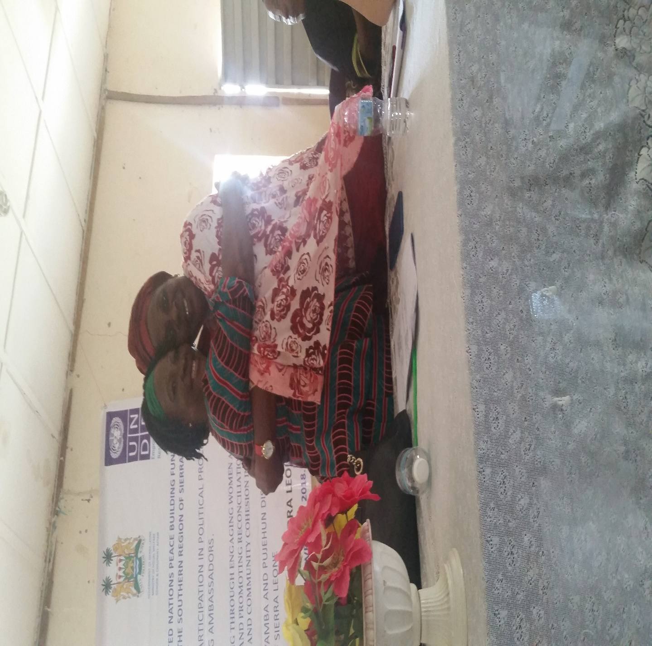

SUCCESS STORY: The Regional Chairladies; Madam Haja Zainab Mansaray for the All People Congress Southern Region and Madam Rose Marie Jalloh (Councilor) for the Sierra Leone Peoples Party publicly declared that political violence is bad, they agreed to put their differences aside, and call for collective support to promote women’s agenda and promote every woman in politics in respective of political and tribal affiliations
QUOTATIONS:
- Madam Haja Zainab Mansaray-Regional Chairlady (All Peoples Congress) “As women, we must be ready to collectively support our fellow women to contest in elections against male candidates in respective of political parties. That is one sure way to defeat male dominance in Sierra Leone political arena. But continuous disunity amongst us women due to our associations to different tribes, regions and political colors have left the door open for male dominance in politics to go largely unchecked”
- Madam Rose Marie Jalloh (Councilor) for the Sierra Leone Peoples Party: “Enough is enough to male dominance in Sierra Leone politics and governance. Women must take the lead now and there could be no better time than now”

